**Lab 09**

**Laboratory Exercise**

**Part 1: Deploy Single Container POD in Kubernetes**

**LAB EXERCISE**

This LAB exercise shows you how to deploy a sample application in kubernetes.

**Time to Complete**

Approximately 15 Minutes

**What You Need**

Kubernetes Cluster should be running. If not start the cluster using the command “minikube start”

Question: What is the main difference between Kubernetes and Minikube?

For YAML Basic Syntax and Meaning, please read <https://docs.ansible.com/ansible/latest/reference_appendices/YAMLSyntax.html>

From your machine logged-in to RP VPN, run Remote Desktop Connection to connect to the ubuntu Linux Virtual Machine (VM). Please login based on your assigned VM as shown below:

|  |  |  |  |  |  |
| --- | --- | --- | --- | --- | --- |
| **S/N** | **Name** | **VM** | **IP Address** | User Name | Password |
| 1 | ABDUL SALIM BIN ABDUL RASHITH | LABC03 - 172.20.115.50 | 172.20.115.50 | dockeradm | docker!2 |
| 2 | CASPER LEOW YU HAN (LIAO YU HANG) | LABC03 - 172.20.115.51 | 172.20.115.51 | dockeradm | docker!2 |
| 3 | CHAN JUN ZHI, GLENN | LABC03 - 172.20.115.52 | 172.20.115.52 | dockeradm | docker!2 |
| 4 | CHIA WAI TAT | LABC03 - 172.20.115.53 | 172.20.115.53 | dockeradm | docker!2 |
| 5 | HOI WAI TECK | LABC03 - 172.20.115.54 | 172.20.115.54 | dockeradm | docker!2 |
| 6 | KOH JIN CAI DAEMIAN | LABC03 - 172.20.115.55 | 172.20.115.55 | dockeradm | docker!2 |
| 7 | KYAW KYAW OO | LABC03 - 172.20.115.56 | 172.20.115.56 | dockeradm | docker!2 |
| 8 | LUM YOKE FAI | LABC03 - 172.20.115.57 | 172.20.115.57 | dockeradm | docker!2 |
| 9 | MUHAMMAD FADHLI BIN MOHAMED NOOR | LABC03 - 172.20.115.58 | 172.20.115.58 | dockeradm | docker!2 |
| 10 | MUHAMMAD HILMEE BIN MD ALI | LABC03 - 172.20.115.59 | 172.20.115.59 | dockeradm | docker!2 |
| 11 | NG SAY WEE | LABC03 - 172.20.115.60 | 172.20.115.60 | dockeradm | docker!2 |
| 12 | NGUI WEILY | LABC03 - 172.20.115.61 | 172.20.115.61 | dockeradm | docker!2 |
| 13 | NU'MAN HARITH BIN NORRAIMI | LABC03 - 172.20.115.62 | 172.20.115.62 | dockeradm | docker!2 |
| 14 | RULY JANUAR FACHMI | LABC03 - 172.20.115.76 | 172.20.115.76 | dockeradm | docker!2 |
| 15 | SEAH SHIH WEI GEROME | LABC03 - 172.20.115.64 | 172.20.115.64 | dockeradm | docker!2 |
| 16 | SEAN CHENG ZHI WEI | LABC03 - 172.20.115.65 | 172.20.115.65 | dockeradm | docker!2 |
| 17 | SEY KOK SIONG | LABC03 - 172.20.115.66 | 172.20.115.66 | dockeradm | docker!2 |
| 18 | TAN JOON YEE DOUGLAS | LABC03 - 172.20.115.67 | 172.20.115.67 | dockeradm | docker!2 |
| 19 | WU WAI TENG VANESSA | LABC03 - 172.20.115.68 | 172.20.115.68 | dockeradm | docker!2 |
| 20 | YAP KOON SING | LABC03 - 172.20.115.69 | 172.20.115.69 | dockeradm | docker!2 |
| 21 | YE CHENG LIM | LABC03 - 172.20.115.70 | 172.20.115.70 | dockeradm | docker!2 |
| 22 | SHAIFUL BIN ABDUL KARIM | LABC03 - 172.20.115.71 | 172.20.115.71 | dockeradm | docker!2 |
| 23 | CHAI RU YI | LABC03 - 172.20.115.72 | 172.20.115.72 | dockeradm | docker!2 |
| 24 | JWAY HWEE LING JULIE | LABC03 - 172.20.115.73 | 172.20.115.73 | dockeradm | docker!2 |
| 25 | SAMANTHA TEO XING YEE | LABC03 - 172.20.115.74 | 172.20.115.74 | dockeradm | docker!2 |
| 26 | ZIL AZZA HILMIAH BINTE RADUAN | LABC03 - 172.20.115.75 | 172.20.115.75 | dockeradm | docker!2 |

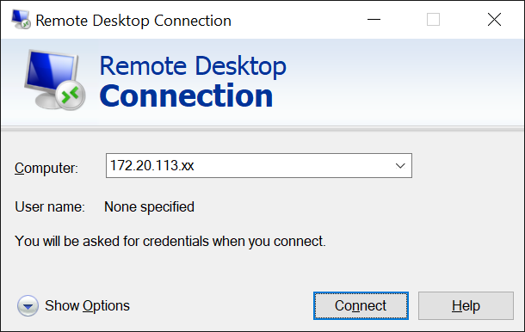

Replace xx with the IP address of the VM that you have been assigned.

**Deploy the Application**

1. Save below db-pod.yml file in the directory ~/lab09 i.e. /home/dockeradm/lab09

apiVersion: v1

kind: Pod

metadata:   
 name: mysql

labels:   
 name: mysql   
 app: demo

spec:   
 containers:   
 - name: mysql   
 image: mysql:latest   
 ports:

- containerPort: 3306   
 protocol: TCP   
 env:   
 - name: "MYSQL_ROOT_PASSWORD"   
 value: "password"

2. Create a POD with single container using the command :

cd /home/dockeradm/lab09

kubectl create -f db-pod.yml

3. Check the PODs via the below command

kubectl get pods

4. Login to the Kubernetes Dashboard and analyze the POD

5. Get the complete details of POD using the command

kubectl describe pod mysql

**Part 2: Deploy multiple PODs and communication between PODs in Kubernetes**

**LAB EXERCISE**

This LAB exercise demonstrates the concept of packaging containers into a pod and communication between pods.

**Time to Complete**

Approximately 30 Minutes

**What You Need**

* Lab 9 - Part 1 to be completed successfully.
* Execute the command: sudo apt install docker-compose
* Kubernetes Cluster should be running. If not start the cluster using the command “minikube start”
* Register a free account on Docker hub <https://www.docker.com/>

**Build a Docker image and push it to docker hub**

1. Sign in to the Docker Hub (Browser) <https://www.docker.com/>

* Using the same credentials launch a new terminal to login into docker: docker login

2. Git clone all the files from the Folder **PODLab** from the provided git url <https://github.com/KeyonGenesis/K8Exercises> and edit the below files in the **Docker** folder as per your docker hub username.

soi-sddo@sddo-vm:~$ *git clone https://github.com/KeyonGenesis/K8Exercises*

soi-sddo@sddo-vm:~$ *cd K8Exercises/lab03/PODLab/Docker*

Edit the following 2 files. Replace the username/repository from keyongenesis/web to your username/ in docker hub.

* Build.sh
* docker-compose.yml

3. From the docker directory, build the image using the below command.

docker build -t <DOCKER_HUB_USERNAME>/web .

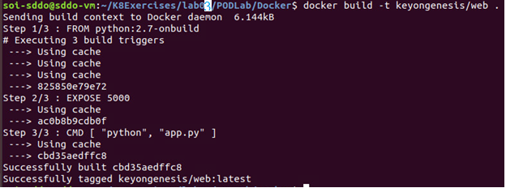

4. Once the build is successful, push the image to your docker hub.

Need to login to your docker hub account first

docker login

Username:

Password:

docker push <DOCKER_HUB_USERNAME>/web

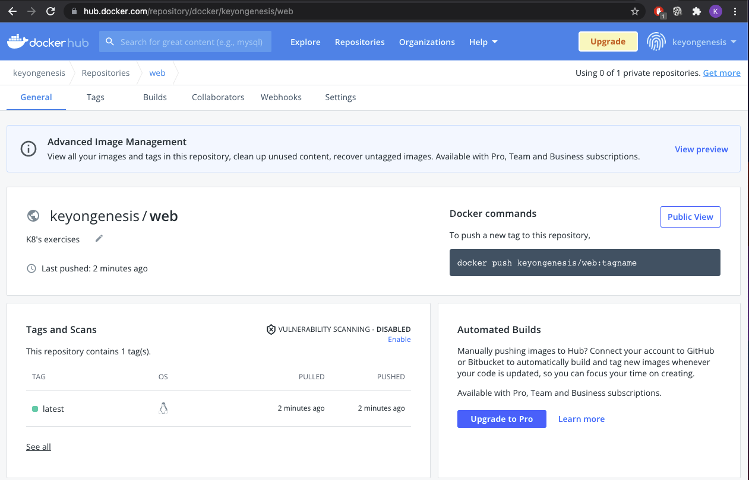

5. To check if the build image is working properly, use the docker compose file to create the container using below command.

docker-compose up -d

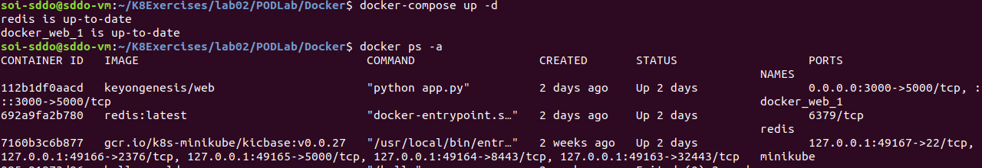

6. Check the container using the below command.

docker ps -a



7. Test the application using the url <http://localhost:3000/> and the output will be as : Hello Container World! I have been seen 1 times.

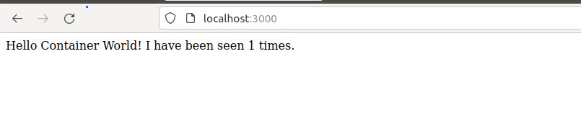

Now your build image is ready to deploy in Kubernetes.

**Part 3: Deploy the Application in Kubernetes**

**LAB EXERCISE**

This LAB exercise demonstrates the concept of packaging containers into a pod and communication between pods.

Before starting part 3, you need to clean up the services and pods created in part 2. You may clean them up via minikube dashboard

Click on each pod or service, and then click on the bin icon.

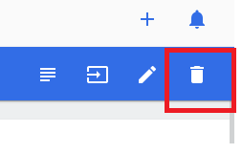

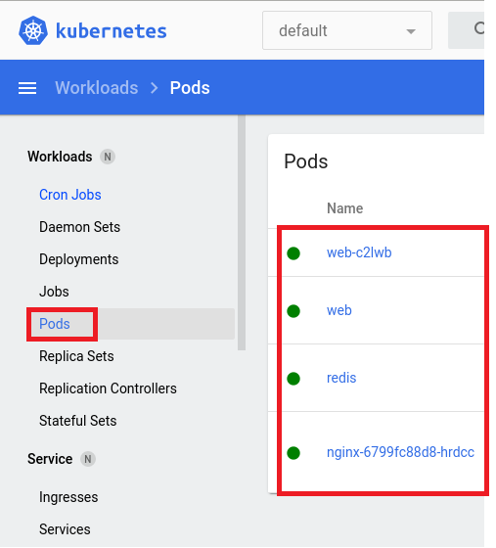 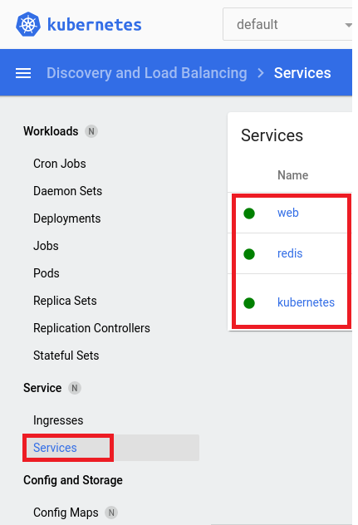

**Time to Complete**

Approximately 30 Minutes

1. Copy all the files from the Folder PODLab from git Location and store it locally. <https://github.com/KeyonGenesis/K8Exercises>

2. Edit the below files in the folder **Kubernetes** as per your docker hub username.

Edit the following files. Replace the username/repository from keyongenesis/web to your username/web in docker hub.

* web-pod.yml
* web-rc.yml

4. Open the command prompt as administrator and create POD service as below   
 cd K8Exercises/lab03/PodLab/Kubernetes/

kubectl create -f db-pod.yml

kubectl create -f db-svc.yml

kubectl create -f web-pod.yml

kubectl create -f web-svc.yml

kubectl create -f web-rc.yml

|  |
| --- |
| <Insert screen capture of results> |

5. Open the command prompt as administrator and create POD service as below   
 kubectl get pods

|  |
| --- |
| <Insert screen capture of results> |

6. Get the list of exposed services.

kubectl get svc

|  |
| --- |
| <Insert screen capture of results> |

7. Get service url for web application using below command.

minikube service web --url

8. Access the url listed above from the browser and verify the result.

Hello Container World! I have been seen 1 times.

**Part 4: Deployment in Kubernetes**

**LAB EXERCISE**

This LAB exercise demonstrates the concept of how to use the service deployment and expose it.

Before starting part 4, you need to clean up the services and pods created in part 3. You may clean them up via minikube dashboard

Click on Deployment, Pods and Services, and then click on the bin icon.



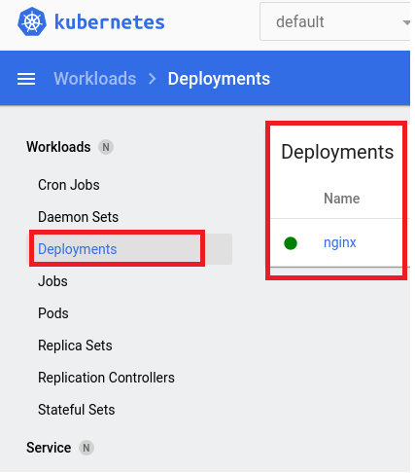  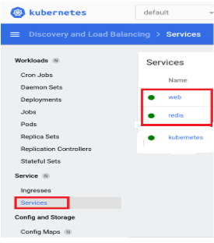

**Time to Complete**

Approximately 30 Minutes

**What You Need**

* Lab 01 to be completed successfully.
* Kubernetes Cluster should be running. If not start the cluster using the command “minikube start”

1. Deploy the Application

1.1 Save this below *deployment.yaml* file in local storage directory K8Exercises/lab03/Deployment

apiVersion: apps/v1

kind: **Deployment**

metadata:

name: tomcat-deployment

spec:

selector:

matchLabels:

app: tomcat

replicas: 2

template:

metadata:

labels:

app: tomcat

spec:

containers:

- name: tomcat

image: tomcat:9.0

ports:

- containerPort: 8080

2. Create a POD service using the command:  
 kubectl create -f deployment.yaml

3. Check the PODs using the below command:  
 kubectl get pods

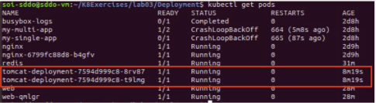

Once the tomcat POD is running, then expose the service.

4. Expose the service using the command:  
 kubectl expose deployment tomcat-deployment --type=NodePort

4.1. Verify the Service is created and is available on a node port:  
 kubectl get service tomcat-deployment

5. Get the minikube service url for this tomcat service using the command:  
 minikube service tomcat-deployment --url

6. Open the browser and access the service URL.

Check the tomcat home page is loading and version.

**Upgrade the Application with different tomcat version**

7. Update deployment of object tomcat to version 8.0 using the command:

kubectl set image deployment/tomcat-deployment tomcat=tomcat:8.0

8. Check the PODs are running using the below command:

kubectl get pods

It will take some time, since the image of the 8.0 version of tomcat needs to be pulled. Once the tomcat POD is running, then expose the service.

9. Expose the service using the command

kubectl expose deployment tomcat-deployment --type=NodePort

10. Get the minikube service url for this tomcat service using the command:

minikube service tomcat-deployment –-url

Open the browser and access the service URL. Check the tomcat home page is loading.

**Rollout the previous deployed version**

11. Rollout the changes applied to the deployment object using the below command.

kubectl rollout undo deployment/tomcat-deployment

12. Get the minikube service url for this tomcat service.

13. Open the browser and access the service URL.

Check the tomcat home page is loading and version.

**--End of Lab Exercise --**

# **External documentations**

Those documentations can help you to go further in this topic :

* Kubernetes official documentation of [the command line](https://kubernetes.io/docs/tasks/tools/install-kubectl/)
* Kubernetes official [command line cheat sheet](https://kubernetes.io/docs/reference/kubectl/cheatsheet/)
* Kubernetes official documentation of [namespace](https://kubernetes.io/docs/concepts/overview/working-with-objects/namespaces/)
* Kubernetes official documentation of [labels](https://kubernetes.io/docs/concepts/overview/working-with-objects/labels/)
* Kubernetes official documentation of [recommended labels](https://kubernetes.io/docs/concepts/overview/working-with-objects/common-labels/)
* Kubernetes [API reference](https://kubernetes.io/docs/reference/generated/kubernetes-api/v1.12/) documentation
* [Kubectl official Reference](https://kubernetes.io/docs/reference/generated/kubectl/kubectl-commands#delete) documentation
* Kubernetes official documentation on [declarative object management](https://kubernetes.io/docs/concepts/overview/object-management-kubectl/declarative-config/)
* Kubernetes official documentation on [imperative object management](https://kubernetes.io/docs/concepts/overview/object-management-kubectl/imperative-config/)